A particle model for the solid and liquid states
Science has the idea that stuff is made from very small particles.
- Imagine you could see the particles in this block of lead.
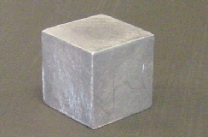
Which diagram best matches what you would see?
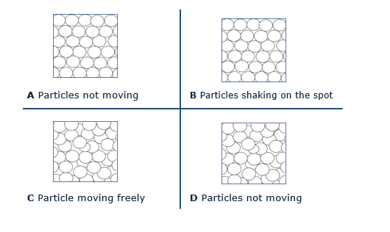

- Imagine you could see the particles in this beaker of water.

Which diagram best matches what you would see?
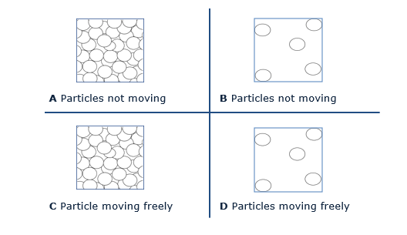

- Here is a block of copper at room temperature.
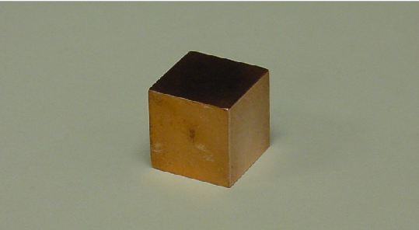
Which of A, B, C or D best describes it?
A It is made of particles which are hard, like tiny bits of solid.
B There are particles in rows surrounded by solid copper.
C It is made of particles which are not like bits of solid copper.
D It does not have any particles.
- Here is some water at room temperature.
Which of A, B, C or D best describes it?
A It is made of particles which are runny, like drops of liquid.
B There are particles dotted about surrounded by liquid water.
C It is made of particles which are not like bits of liquid.
D It does not have any particles.

Chemistry > Big idea CPS: Particles and structure > Topic CPS1: Particle model > Key concept CPS1.1: Particle model for the solid, liquid and gas states
Diagnostic question
A particle model for the solid and liquid states

Learning focus: | Understand a basic particle model of matter that can explain the properties of substances in the solid and liquid states.
Observable learning outcome: | Describe the arrangement and movement of particles in a substance in the solid and liquid states.
Question type: | simple multiple choice
Key words: | particle, solid, liquid, state

What does the research say?
Research by Johnson (1998) shows that students’ particle diagrams often show the spacing for particles in a liquid as being in between the spacing for the solid state and the gas state.
It has also shown that students have very little appreciation of the idea of the intrinsic motion of particles. This leads to students to have difficulties in explaining observed diffusion of a dye through water or in understanding air pressure.
Ways to use this question
Students should complete the question individually. This could be a pencil and paper exercise, or you could use an electronic ‘voting system’ or mini white boards and the PowerPoint presentation.
The answers to the question will show you whether students understood the concept sufficiently well to apply it correctly.
If there is a range of answers, you may choose to respond through structured class discussion. Ask one student to explain why they gave the answer they did; ask another student to explain why they agree with them; ask another to explain why they disagree, and so on. This sort of discussion gives students the opportunity to explore their thinking and for you to really understand their learning needs.
Expected answers
1 B 2 C 3 C 4 C
How to respond - what next?
Question 1 addresses the intrinsic motion of particles that make up a substance in the solid state. The idea of intrinsic motion for the solid state is the most difficult for students to understand. If students think macroscopically about the particles it is difficult to see why they would be vibrating. For those thinking of particles being embedded ‘in the solid’, the particles certainly wouldn’t be moving.
Question 2 addresses both intrinsic motion of particles and spacing. Both options C and D are correct for the motion but in D the particles are too far apart. The idea of intrinsic motion is easier for the liquid state than the solid state probably because bulk movement within the liquid state is familiar to students. Since the image shows a still sample of water some students who are thinking macroscopically may choose option A or B

Question 3 addresses the relationship between particles and the substance and the nature of the particles themselves for the solid state. Appreciating that the macroscopic properties of the solid state are explained by the collective behaviour of the particles and not their individual ‘physical’ character is not easy. Option A is likely to be selected by students who think that the particles have the macroscopic properties of the substance. Option B suggests that the student is still holding onto a continuous model of matter and is adding particles to this existing mental model. Option D suggests that the student is still not thinking of substances as being made up of particles.

Question 4 also addresses the relationship between particles and the substance and the nature of the particles themselves for the liquid state. The correct answer, option C, requires students to appreciate that the macroscopic properties of the liquid state are explained by the collective behaviour of the particles and not their individual ‘physical’ character. Option A suggests the student is thinking that the particles have the macroscopic properties of the substance. Option C implies the student is thinking of particles embedded within a continuous substance. Option D indicates that the student is still not thinking of particles at all.
If students have misunderstandings about the intrinsic movement of particles in a solid this could be demonstrated using marbles and the plastic insert for chocolates (or a meatballs tray). By placing the marbles in the holes in the tray it can be shaken thereby demonstrating that it is possible for particles to shake on the spot and yet still be in fixed positions.
If students have misunderstandings about the particle nature of matter, for example if they are still holding onto the model that a substance is continuous, students could discuss an incorrect particle diagram that shows continuous matter.
The following BEST ‘response activity’ could be used in follow-up to this diagnostic question:
- Particle diagram – the liquid states
Acknowledgments
Developed by Helen Harden (UYSEG), from questions selected from a collection of ASK items devised for research by Philip Johnson and teacher support material developed for York Science by Andrew Hunt.
Images: ASK items
References
Johnson, P. (1998). Progression in children’s understanding of a ‘basic’ particle theory: a longitudinal study. International Journal of Science Education. 20(4) 393-412

